**How to create a simple Login Screen project Using Android Studio?**

Step 1  – Create new Android project.

Provide Activity name as ***Login***as shown below

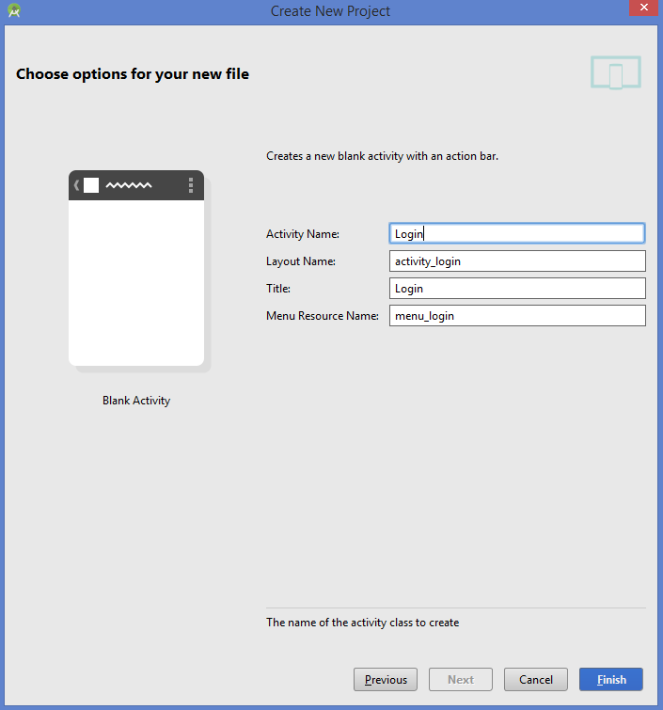

Android Login Screen Example Login Activity

 Step 2 – Add components in the main activity as shown in the picture below.

**[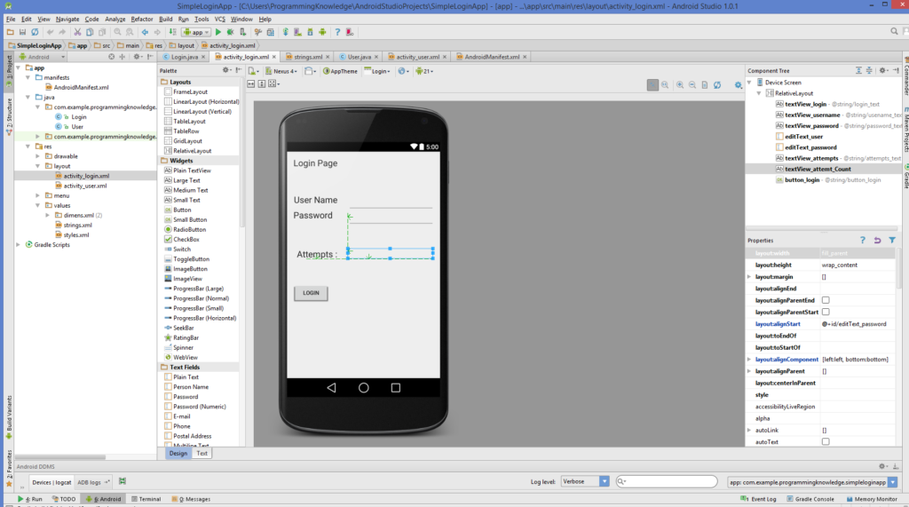](http://www.codebind.com/wp-content/uploads/2016/07/Android-Login-Screen-Example-Design.png)**Android Login Screen Example Design

**SimpleLoginApp\app\src\main\res\layout\activity_login.xml**

|  |  |
| --- | --- |
| 1  2  3  4  5  6  7  8  9  10  11  12  13  14  15  16  17  18  19  20  21  22  23  24  25  26  27  28  29  30  31  32  33  34  35  36  37  38  39  40  41  42  43  44  45  46  47  48  49  50  51  52  53  54  55  56  57  58  59  60  61  62  63  64  65  66  67  68  69  70  71  72  73  74  75  76  77  78  79  80  81  82  83  84  85  86  87  88 | <RelativeLayout xmlns:android="<http://schemas.android.com/apk/res/android>"      xmlns:tools="<http://schemas.android.com/tools>" android:layout_width="match_parent"      android:layout_height="match_parent" android:paddingLeft="@dimen/activity_horizontal_margin"      android:paddingRight="@dimen/activity_horizontal_margin"      android:paddingTop="@dimen/activity_vertical_margin"      android:paddingBottom="@dimen/activity_vertical_margin" tools:context=".Login">        <TextView          android:layout_width="wrap_content"          android:layout_height="wrap_content"          android:textAppearance="?android:attr/textAppearanceLarge"          android:text="@string/login_text"          android:id="@+id/textView_login"          android:layout_alignParentTop="true"          android:layout_alignParentLeft="true"          android:layout_alignParentStart="true" />        <TextView          android:layout_width="wrap_content"          android:layout_height="wrap_content"          android:textAppearance="?android:attr/textAppearanceLarge"          android:text="@string/usename_text"          android:id="@+id/textView_username"          android:layout_marginTop="66dp"          android:layout_below="@+id/textView_login"          android:layout_alignRight="@+id/textView_login"          android:layout_alignEnd="@+id/textView_login" />        <TextView          android:layout_width="wrap_content"          android:layout_height="wrap_content"          android:textAppearance="?android:attr/textAppearanceLarge"          android:text="@string/password_text"          android:id="@+id/textView_password"          android:layout_below="@+id/editText_user"          android:layout_alignParentLeft="true"          android:layout_alignParentStart="true" />        <EditText          android:layout_width="wrap_content"          android:layout_height="wrap_content"          android:inputType="textPersonName"          android:ems="10"          android:id="@+id/editText_user"          android:layout_alignTop="@+id/textView_username"          android:layout_alignParentRight="true"          android:layout_alignParentEnd="true" />        <EditText          android:layout_width="wrap_content"          android:layout_height="wrap_content"          android:inputType="textPassword"          android:ems="10"          android:id="@+id/editText_password"          android:layout_below="@+id/editText_user"          android:layout_alignLeft="@+id/editText_user"          android:layout_alignStart="@+id/editText_user" />        <TextView          android:layout_width="wrap_content"          android:layout_height="wrap_content"          android:textAppearance="?android:attr/textAppearanceLarge"          android:text="@string/attempts_text"          android:id="@+id/textView_attempts"          android:layout_below="@+id/editText_password"          android:layout_marginTop="59dp"          android:layout_alignRight="@+id/textView_username"          android:layout_alignEnd="@+id/textView_username" />        <TextView          android:layout_width="fill_parent"          android:layout_height="wrap_content"          android:textAppearance="?android:attr/textAppearanceLarge"          android:id="@+id/textView_attemt_Count"          android:layout_alignBottom="@+id/textView_attempts"          android:layout_alignLeft="@+id/editText_password"          android:layout_alignStart="@+id/editText_password" />        <Button          android:layout_width="wrap_content"          android:layout_height="wrap_content"          android:text="@string/button_login"          android:id="@+id/button_login"          android:layout_below="@+id/textView_attempts"          android:layout_alignLeft="@+id/textView_password"          android:layout_alignStart="@+id/textView_password"          android:layout_marginTop="60dp" />  </RelativeLayout> |

Now Chenge the AndroidManifest.xml file as shown in the code below:

**\SimpleLoginApp\app\src\main\AndroidManifest.xml**

|  |  |
| --- | --- |
| 1  2  3  4  5  6  7  8  9  10  11  12  13  14  15  16  17  18  19  20  21  22  23  24  25  26  27  28  29  30 | <?xml version="1.0" encoding="utf-8"?>  <manifest xmlns:android="<http://schemas.android.com/apk/res/android>"      package="com.example.programmingknowledge.simpleloginapp" >        <application          android:allowBackup="true"          android:icon="@drawable/ic_launcher"          android:label="@string/app_name"          android:theme="@style/AppTheme" >          <activity              android:name=".Login"              android:label="@string/app_name" >              <intent-filter>                  <action android:name="android.intent.action.MAIN" />                    <category android:name="android.intent.category.LAUNCHER" />              </intent-filter>          </activity>          <activity              android:name=".User"              android:label="@string/title_activity_user" >              <intent-filter>                  <action android:name="com.example.programmingknowledge.simpleloginapp.User" />                    <category android:name="android.intent.category.DEFAULT" />              </intent-filter>          </activity>      </application>    </manifest> |

Now go to values\strings.xml and change it as shown n the code

**\SimpleLoginApp\app\src\main\res\values\strings.xml**

|  |  |
| --- | --- |
| 1  2  3  4  5  6  7  8  9  10  11  12  13  14  15 | <?xml version="1.0" encoding="utf-8"?>  <resources>        <string name="app_name">SimpleLoginApp</string>      <string name="hello_world">Hello world!</string>      <string name="action_settings">Settings</string>      <string name="title_activity_user">User</string>      <string name="login_text">Login Page</string>      <string name="usename_text">User Name</string>      <string name="password_text">Password</string>      <string name="attempts_text">Attempts :</string>      <string name="button_login">Login</string>      <string name="Secon_page_text">Welocome to the Second Page</string>    </resources> |

Step 3 Add the new activity . Right Click Project -> New -> Activity -> Blank Activity

Give the name to your activity  ***User***

**[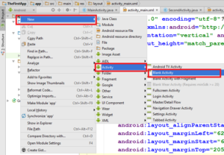](http://www.codebind.com/wp-content/uploads/2016/07/create-blank-activity.png)**create blank activity

write the following code

SimpleLoginApp\app\src\main\res\layout\activity_user.xml

|  |  |
| --- | --- |
| 1  2  3  4  5  6  7  8  9  10  11  12  13  14  15  16  17  18  19 | <RelativeLayout xmlns:android="<http://schemas.android.com/apk/res/android>"      xmlns:tools="<http://schemas.android.com/tools>" android:layout_width="match_parent"      android:layout_height="match_parent" android:paddingLeft="@dimen/activity_horizontal_margin"      android:paddingRight="@dimen/activity_horizontal_margin"      android:paddingTop="@dimen/activity_vertical_margin"      android:paddingBottom="@dimen/activity_vertical_margin"      tools:context="com.example.programmingknowledge.simpleloginapp.User"      android:id="@+id/user_layout">        <TextView          android:layout_width="wrap_content"          android:layout_height="wrap_content"          android:textAppearance="?android:attr/textAppearanceLarge"          android:text="@string/Secon_page_text"          android:id="@+id/textView"          android:layout_alignParentTop="true"          android:layout_centerHorizontal="true"          android:layout_marginTop="137dp" />  </RelativeLayout> |

com/example/programmingknowledge/simpleloginapp/Login.java

|  |  |
| --- | --- |
| 1  2  3  4  5  6  7  8  9  10  11  12  13  14  15  16  17  18  19  20  21  22  23  24  25  26  27  28  29  30  31  32  33  34  35  36  37  38  39  40  41  42  43  44  45  46  47  48  49  50  51  52  53  54  55  56  57  58  59  60  61  62  63  64  65  66  67  68  69  70  71  72  73  74  75  76  77  78  79  80  81  82 | package com.example.programmingknowledge.simpleloginapp;    import android.content.Intent;  import android.support.v7.app.ActionBarActivity;  import android.os.Bundle;  import android.view.Menu;  import android.view.MenuItem;  import android.view.View;  import android.widget.Button;  import android.widget.EditText;  import android.widget.TextView;  import android.widget.Toast;      public class Login extends ActionBarActivity {      private static EditText username;      private static EditText password;      private static TextView attempts;      private static Button login_btn;      int attempt_counter = 5;  *@Override*      protected void onCreate(Bundle savedInstanceState) {          super.onCreate(savedInstanceState);          setContentView(R.layout.activity_login);          LoginButton();      }        public  void LoginButton() {          username = (EditText)findViewById(R.id.editText_user);          password = (EditText)findViewById(R.id.editText_password);          attempts = (TextView)findViewById(R.id.textView_attemt_Count);          login_btn = (Button)findViewById(R.id.button_login);            attempts.setText(Integer.toString(attempt_counter));            login_btn.setOnClickListener(                  new View.OnClickListener() {  *@Override*                      public void onClick(View v) {                          if(username.getText().toString().equals("user") &&                                  password.getText().toString().equals("pass")  ) {                              Toast.makeText(Login.this,"User and Password is correct",                                      Toast.LENGTH_SHORT).show();                              Intent intent = new Intent("com.example.programmingknowledge.simpleloginapp.User");                              startActivity(intent);                          } else {                              Toast.makeText(Login.this,"User and Password is not correct",                                      Toast.LENGTH_SHORT).show();                              attempt_counter--;                              attempts.setText(Integer.toString(attempt_counter));                              if(attempt_counter == 0){                                  login_btn.setEnabled(false);                              }                          }                        }                  }          );      }    *@Override*      public boolean onCreateOptionsMenu(Menu menu) {          // Inflate the menu; this adds items to the action bar if it is present.          getMenuInflater().inflate(R.menu.menu_login, menu);          return true;      }    *@Override*      public boolean onOptionsItemSelected(MenuItem item) {          // Handle action bar item clicks here. The action bar will          // automatically handle clicks on the Home/Up button, so long          // as you specify a parent activity in AndroidManifest.xml.          int id = item.getItemId();            //noinspection SimplifiableIfStatement          if (id == R.id.action_settings) {              return true;          }            return super.onOptionsItemSelected(item);      }  } |

com/example/programmingknowledge/simpleloginapp/User.java

|  |  |
| --- | --- |
| 1  2  3  4  5  6  7  8  9  10  11  12  13  14  15  16  17  18  19  20  21  22  23  24  25  26  27  28  29  30  31  32  33  34  35  36  37  38  39 | package com.example.programmingknowledge.simpleloginapp;    import android.support.v7.app.ActionBarActivity;  import android.os.Bundle;  import android.view.Menu;  import android.view.MenuItem;      public class User extends ActionBarActivity {    *@Override*      protected void onCreate(Bundle savedInstanceState) {          super.onCreate(savedInstanceState);          setContentView(R.layout.activity_user);      }      *@Override*      public boolean onCreateOptionsMenu(Menu menu) {          // Inflate the menu; this adds items to the action bar if it is present.          getMenuInflater().inflate(R.menu.menu_user, menu);          return true;      }    *@Override*      public boolean onOptionsItemSelected(MenuItem item) {          // Handle action bar item clicks here. The action bar will          // automatically handle clicks on the Home/Up button, so long          // as you specify a parent activity in AndroidManifest.xml.          int id = item.getItemId();            //noinspection SimplifiableIfStatement          if (id == R.id.action_settings) {              return true;          }            return super.onOptionsItemSelected(item);      }  } |

Now Run your app

Output:

**[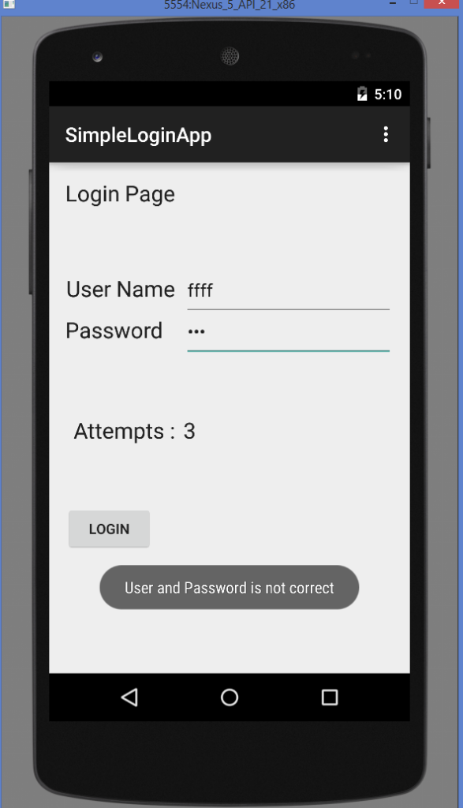](http://www.codebind.com/wp-content/uploads/2016/07/Android-Login-Screen-Example-Output-wrong-user-and-password.png)**

Android Login Screen Example Output wrong user and password

**[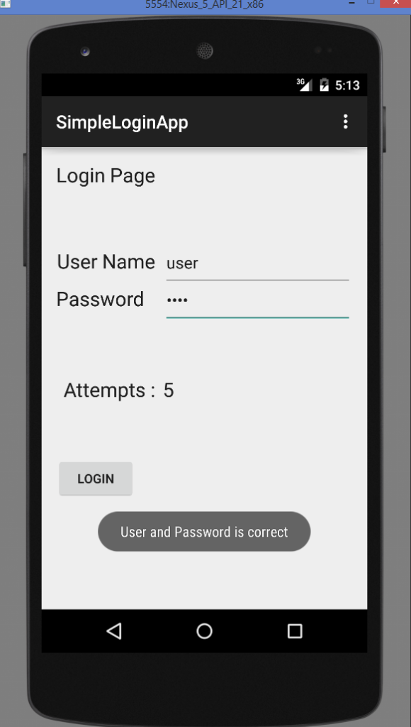](http://www.codebind.com/wp-content/uploads/2016/07/Android-Login-Screen-Example-Output-correct-user-and-password.png)**

Android Login Screen Example Output correct user and password

**[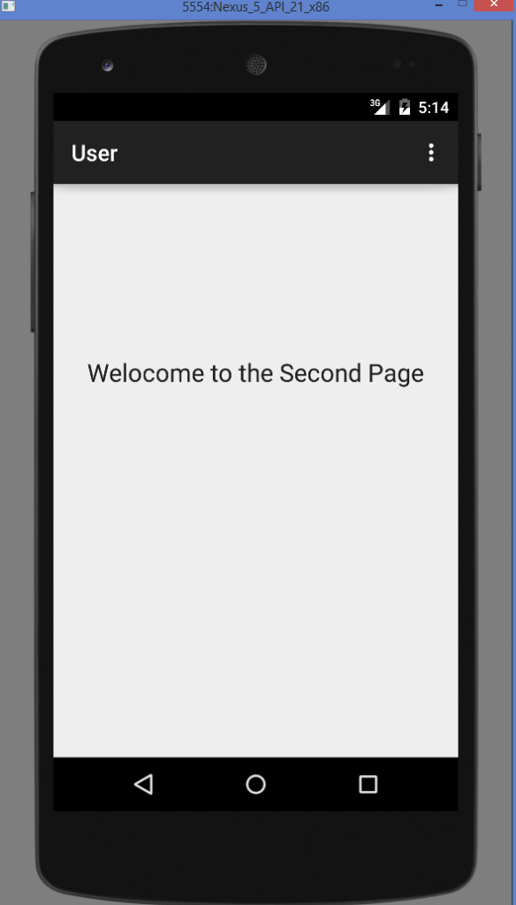](http://www.codebind.com/wp-content/uploads/2016/07/Android-Login-Screen-Example-Output-correct-user-and-password-Next-activity.png)**

Android Login Screen Example Output correct user and password Next activity